|  |  |
| --- | --- |
| **Y JUT PRIMARY SCHOOL**  **Name: …………………………**  **Class: …………** | **THE FIRST TERM TEST FOR GRADE 5**  **School year : 2020-2021**  **Time: 35 minutes** |

***Part I. LISTENING ( 2.5pt)***

***Question 1. Listen and tick . There is one example ( 1p)***

1. *What does Mai want?*

|  |  |  |  |  |  |  |  |  |
| --- | --- | --- | --- | --- | --- | --- | --- | --- |
|  | a. |  |  | b. | Description: MC900434713[1] |  | c. |  |
|  | 1. a. |  |  | b. |  |  | c. |  |

*2 a.*  *** b. 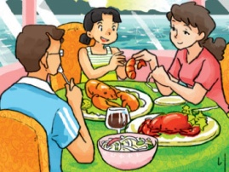 c.*** 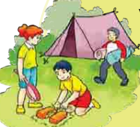

*3. a.  b. 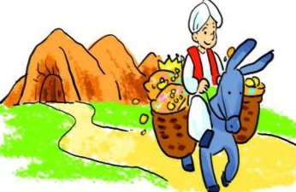 c.* 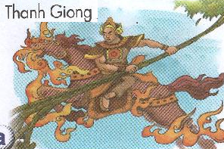

|  |  |  |  |  |  |  |  |  |
| --- | --- | --- | --- | --- | --- | --- | --- | --- |
| 4. | a. | Description: watch videos |  | b. |  |  | c. |  |

***Question 2:******Listen and tick Description: MC900434713[1]T ( True) or F ( False ). There is one example. ( 0.75p)***

Example:

|  |  |  |
| --- | --- | --- |
|  | **T** | **F** |
| 1. Nam always brushes his teeth after getting up. |  | **Description: MC900434713[1]** |
| 2. Quan has Maths every school day. |  |  |
| 3. He learns English because he wants to be an English teacher. |  |  |
| 4. She lives at Flat 80 on the second floor of Hanoi Tower. |  |  |

***Question 3: Listen and complete. There is one example.( 0.75 p)***

*Example:* 1. Interviewer: What do you often do in the evening, Alex? Alex: I often do my (0)  **homework.**

1. Hello, My name is Mai. My home town is in the south of Vietnam. It’s by the sea. I go back to my hometown once or twice a year. Last month, I (1)……… there by plane.
2. A: What did you do at the party?

B: We (2)…………… cartoons.

1. A: How do you practice reading English?

A: I read (3)……………………. comic books.

***Part II. READING ( 2.5 pt)***

***Question 1. Read and match.* (0,75pt)**

|  |  |
| --- | --- |
| ***0. Where are you from?*** | A. I read short story. |
| 1. When will Teachers’ Day be? | B. He’s hard-working |
| 2. What’s An Tiem like? | ***C. I’m from Vietnam.*** |
| 3. How do you practise read English? | D. It’ll be on Saturday. |

**Question 2: Read and tick True or False(1pt)**

Mai is a student at Tan An Primary school. There are forty students in her class. Today she has Maths, Music and Art. She likes Music because she likes to sing. She doesn’t go to school on Saturday and Sunday.

|  |  |  |
| --- | --- | --- |
| Statement | T | F |
| 1. She is a student. |  |  |
| 2. There are six students in her class. |  |  |
| 3. Today she has Vietnamese, English and Science. |  |  |
| 4.She doesn’t go to school on Saturday and Sunday. |  |  |

**Question 3: Read and complete (0,75pt)**

do play usually is

Hi. My name (0) is Nam. Every morning, I get up early . I (1)_____________ morning exercise , have breakfast and then go to school . After school, I(2)___________ do homework with my classmates . Then I often go to the sports centre and (3)_________ football.

***Part III. WRITING ( 2.5 pt)***

**Question 1: Look at the picture and the letters. Write the words.(1pt)**

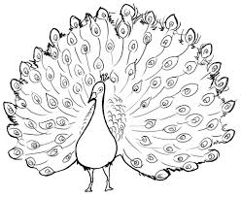

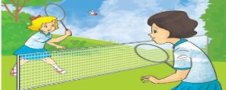

1.badm_ _ton 2_ _acock

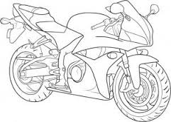

3. c_ _ toon 4. *Mo _ _ _****bike***

**Question 2. Order the word to make sentences. There is an example (0,75 mark)**

**Example:**  / I / VietNam / from/***.***

**🡪***I am from Viet Nam.*

1.am / Crow./reading / and/ I / the/ the/Fox 🡪_________________________________

2.Where/next/Phong/week/will/be/? 🡪___________________________________

3.at/peacocks/zoo./saw/pythons/I/and/the🡪___________________________________

**Question 3: Write the answer(0,75pt)**

1. How do you practise speaking English?

…………………………………………….

1. How many seasons are there in Dak Lak?

……………………………………………

1. What are you going to do on Sport Day?

................................................................

**IV- SPEAKING (2,5pt)**

**I: Introduction (0,75pt)**

1. What is your name?
2. How old are you?
3. What’s your hobby?

**II. Answer questions**.(**1pt)**

1. What did you see? 2. What did they do at the party?

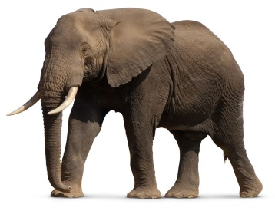 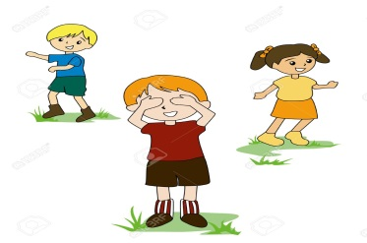

3. What is he doing ? 4. What’s the village like?

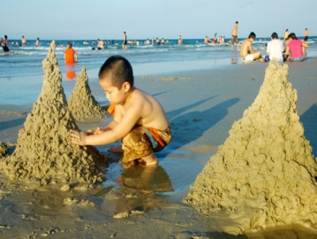 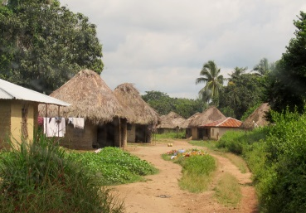

**III: Tell about your favourite lesson (0,75pt)**

|  |  |
| --- | --- |
| 1. How many lessons do you have today?  2. What’s your favourite lesson?  3. How often do you have it? |  |